DATE : 13.06.2018
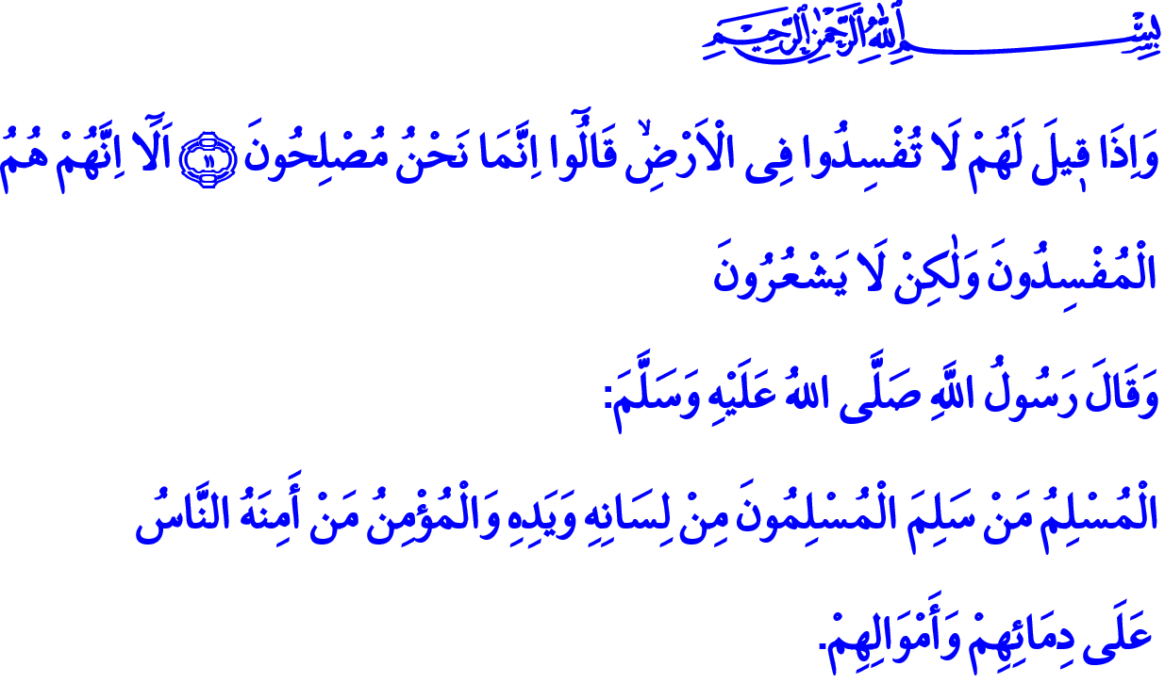
JULY 15 – REBIRTH OF A NATION
Jumu’ah Mubarak Honorable Believers!
The homeland we inhabit is not just a piece of soil. It is the land of our forefathers. It is a trust from the martyrs. Homeland is the land where we cherish heartily and for which we sacrifice our lives so that we move forward to the future with firm steps.
We have held to our homeland with affection and loyalty throughout history. We walked towards martyrdom for our sacred values without batting an eyelid. We had a matchless fight for survival despite poverty and penury at Çanakkale and at the War of Independence. But we never retreated. We rendered our chests as armors against many disgraceful assaults. With Allah’s (s.w.t.) grace and help, and our courage and dedication, we won great victories.
On the night of July 15, the salas we recited until the morning, takbirs, prayers and beseechings united with the prayers of believing brothers of ours from all corners of the world for the salvation of our nation. United wholeheartedly as a nation, we flooded the squares. We put a lid altogether on this treacherous assault directed at our unity and solidarity, at our independence and future. With that spectacular spirit we derived from our faith and love for the country, we rebutted the treacherous desires. With our foresight, vision and equanimity, we returned from the threshold of a huge disaster.
Honorable Muslims!
Our Lord Almighty (s.a.w.) enjoins in the verse I have recited at the beginning of my khutbah, “And when it is said to them, ‘Do not cause corruption on the earth’, they say, ‘We are but reformers.’ Unquestionably, it is they who are the corrupters, but they perceive [it] not.”
Dear Muslims!
The invasion attempt we were subjected to on the night of July 15 was cloaked in the guise of religion. Seeming to favor the truth yet serving the falsity, the terrorist organization FETO abused our faith, our moral sensitivities, our love for the Prophet (s.a.w.), our zakat and sadaqah, our sacrifices, in short all our religious values and concepts. They had a design against our nation, our unity and solidarity, and the future of our country for their own interests.
These traitors tried to separate children from their families and remove their love for the country and the awareness for the Ummah from their hearts. They dragged our people into the swirls of insecurity by abusing religious feelings in the guise of peace and betterment. But, as expressed by our Prophet (s.a.w.), “Muslim is the one from (the harm of) whose tongue and hand (other) Muslims are safe, and the believer is the one whom people trust regarding their lives and their wealth.”
Dear Believers!
We have a book, in which not even a single letter has been altered, a prophet whose whole life is known in its clarity, and a religion whose basic principles are quite obvious. Those who try to build a so-called Islamic world upon dreams, mysteries and devious plans will never succeed. It should be noted that those who abuse our religion for their hideous purposes by mentioning Allah (s.w.t.) and His Messenger (s.a.w.) will always end up in disappointment. This disappointment will seize them in abasement in this world, and in torment in the afterlife.
Venerable Muslims!
Our duty is to not establish a sublime truth such as religion on individuals in order to prevent any recurrence of the July 15. We should not entrust our intelligence, our will, and our conscience to anybody without questioning. We should learn Islam from the correct sources, from rightminded and trustworthy people. We should live our lives in the guidance of the Holy Qur’an and the Sunnah of our Beloved Prophet (s.a.w.). We should know that all approaches except the prudent path on which the majority of Muslims, from the generation of the Companions to this day, are deviant of the true path. We should not give credit to those who invite us to servitude to themselves instead of to Allah (s.w.t.). We should protect the Anatolian wisdom, which came into being for centuries in our homeland and sustained our religious life.
Honorable Believers!
In this hour when Our Lord (s.w.t.) accepts prayers, let us all beseech Him.
O Lord! Protect us from all internal and external disasters to undermine the perpetuity of our religion, our country, our nation, and the Islamic World.
O Lord! Do not give a chance to those who desire to burn us with the flames of disorder, and have designs against our dignity, honor and brotherhood.
O Allah! Protect us from all kinds of disunion, discord and violence which overshadow our unity, amity and affection.
O Allah! Do not deprive this honorable nation, who believe in You, of your help, your grace, your support and your mercy!
O Lord of the Worlds! Bestow mercy upon our martyrs who sacrificed their lives for the perpetuity of this sacred homeland and bestow upon our veterans health and a benevolent life for the sake of Your name al-Shafi (the Curer).
O Allah! Grant us the chance to be a generation worthy of them!

Baqarah, 2/11-12.
Tirmidhi, Iman, 12. General Directorate of Religious Services

